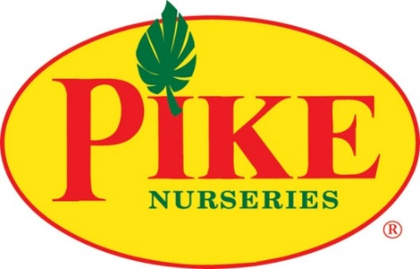

For more information:
Shaye Gulotta
BRAVE Public Relations
404.233.3993
sgulotta@emailbrave.com

FOR IMMEDIATE RELEASE

Pike Nurseries recommends heat-loving plants to survive and thrive this summer
Helpful advice from local garden center experts to have fun in the sun

ATLANTA (August 3, 2020) – Hardworking gardeners can relax and bask in the summer sunshine with the help of the experts at Pike Nurseries, offering advice on plants that can take the heat and look gorgeous while doing it. The foolproof method to beat the heat in the garden is planting tolerant annuals and perennials. Green thumbs of all skill levels can fill garden beds, containers and hanging baskets with a host of plants that resist sizzling temps, proving that summer can be as colorful and flower-filled as spring.

Heat-loving Plants:
Caladiums – These tropical foliage plants, adored for their big, heart-shaped leaves, thrive in southern summer heat but require full to partial shade to perform best. Caladiums come in attractive patterns in hues of white, pink and red.

Coreopsis – These brilliant waterwise perennials have fine textured foliage and small stems that provide waves of daisy-like flowers in cranberry, bright yellow, garnet red, bright pink and scarlet. Coreopsis is a great pollinator-attracting flower, enticing butterflies and bees with its blooms in summer as well as birds with its seeds in fall.

Daylilies – Blooming from late spring through summer, these waterwise, deer-resistant perennials love full sun but can tolerate light shade. Although the gorgeous blooms are short-lived, this southern garden staple reblooms and produces an abundance of flowers all season long!

Hibiscus – These beautiful tropical flowers are available as both annuals and perennials in the southeast region, with colors ranging from white, yellow, orange to red, pink and purple. Hibiscus needs regular watering and should be planted in full sun.

Lantana – Lantana is a classic and low-care choice, available in annual and perennial options. These sun-loving multicolored flowers come in red, orange, yellow, white and pink. Plus, butterflies cannot resist lantana – plant along vegetable gardens and crops that need to be pollinated.

Succulents and sedums – Holding water in their roots and leaves, succulents and sedums perform well in drier spells and give a southwestern feel to waterwise gardens. While popular in indoor container gardens or as desk plants, some varieties prefer to be outdoors in the sun and can even tolerate the mild outdoor winters of the southeast!

Vinca – These sun-loving blooms are attractive, high-performing and disease-resistant plants. Vincas are low-maintenance, waterwise annuals that provide abundant flowers for pots, hanging baskets and garden beds.

Zinnias – These longtime garden favorites will attract bees and butterflies due to their pops of vivid colors in the sunniest locations. Zinnias are long-lasting annuals that are also waterwise and relatively pest-resistant, gracing flower beds and container gardens from spring to the first frost of fall.

For more information and care tips at Pike Nurseries, please visit pikenursery.com.

###
ABOUT PIKE NURSERIES
Ever committed to its customers’ gardening success, Pike Nurseries takes pride in taking the guesswork out of gardening and helping its customers play in the dirt. Offering superior knowledge, quality and selection in a friendly, caring environment, Pike Nurseries has been an Atlanta icon for over 60 years. Founded in 1958 by Pete Pike, its ability to adapt to market conditions and community needs has made Pike Nurseries a respected Southern institution. As Atlanta’s oldest garden chain, Pike Nurseries has 18 retail locations in the Atlanta, Ga. and Charlotte, N.C. areas. Led by President Monte Enright, Pike Nurseries looks forward to continued growth as it keeps Atlanta and Charlotte beautiful, one landscape at a time.

Visit Pike Nurseries on Facebook, Instagram, Pinterest and Twitter.

